MS Office Excel (Project 6B)
Welcome back! In this next tutorial, I created a template and a worksheet, based on a template. A template is a pre-designed worksheet that can be used to create new worksheets with the same layout, formatting, and formulas. Basically, a template is a starting backbone piece that saves me time from starting fresh with a new blank workbook. With templates, I don't have to worry about creating basic elements every single time from scratch, because they’re already being used in the spreadsheet. I created, formatted, and edited a booth registration order form template for use by Job Fair staff to make sure that totals for items ordered are calculated correctly.

First, I selected column B, right-clicked, and chose “Column Width”. In the “Column Width” pop-up window, I typed “21.5.” Next, I right-aligned the ranges of B6:B15, C10:C15, and C6:C7. Then, I selected the ranges of C6:C7 and C10:C15, navigated to the “Home” tab, went to the “Font” group, clicked “Borders”, and selected “More Borders”. In the “Format Cells” pop-up window, I chose the second option in the “Style” section. Under “Border”, I chose “Middle” and “Bottom”.

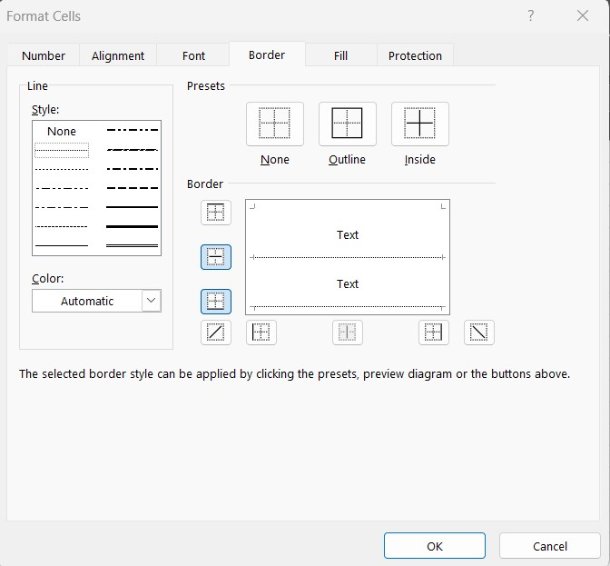

Inserting borders on cells in a template creates lines as a place to keep track of information when the form is filled out. This gives a solid indication to a person filling out a form, in terms of where that information needs to go. I repeated this step for the range of B17:F40. But this time, I set the “Presets” to both “Outline” and “Inside”.

After I entered and formatted my text, I added formulas to the cells. This is where I wanted the result of the calculations to show. I created a formula in the “Total column” to determine the dollar value for the quantity of each item ordered. Then, I created another formula to sum the “Total” column. In cell F18, I typed “=D18*E18” and used the fill-down tool to drag this formula down vertically from F19 to F39. I also applied the “Comma Style” to this range. Then, I added the “AutoSum” to cell F40. Next, I merged and centered the range of D40:E40. In this new merged cell, I typed “Order Total” and aligned the text to the right with a bold format.

Just like I inserted my borders for the ranges of C6:C7 and C10:C15, I followed the same steps for the range of B40:C40. But this time, I removed the “Left”, “Middle Vertical”, & “Bottom” borders so that only the right and top ones are remaining.

My next step was to add a logo to the form. I clicked cell A1, navigated to the “Insert” tab, went to the “Illustrations” group, and chose “Pictures”. After I selected the “Logo” file from my local files, I got a “Picture Format” tab. I went to the “Picture Styles” group and chose the last style in the third row, “Bevel Rectangle.”

Now that I got my logo done, I added WordArt to my form. WordArt is a feature where I can insert decorative text in my document, to create an image with style for a heading or logo. Since WordArt is a graphical object, it can be moved and resized. I can also change its shape and color. I created and modified a vertical WordArt heading and placed it on the left side of the order form grid. I clicked cell A17, navigated to the “Insert” tab, went to the “Text” group, and clicked “WordArt”. I selected the first option in the third row, “Fill - Black, Text 1, Outline - Background 1, Hard Shadow, Background 1.” I typed “Order Booth Form”, went to the “Arrange” group, chose “Rotate”, and selected “Rotate Left 90 Degrees”. Then, I aligned the text from the top of cell A17 to the lower edge of cell A39. Next, I went to the “Shapes Styles” group, clicked the “Shape Fill” arrow, and chose the last texture in the fourth row, “Stationery.”

My last, final step was to create a worksheet, based on my template. First, I saved a copy of the “Booth Order” workbook as “Topaz Order.” Next, I entered in the information. In cell C6, I typed in “October 13, 2016”. For the booth number in cell C10, I typed in “A-3421.” Starting in cell C10, I entered in the following company information:

- Name: Peter Marsden
- Organization: Topaz Industries, Inc.
- Address: 6553 Riverside Drive
- City, State, Zip: Fort Worth, TX 76111
- Phone: 214.555.0230
- Email: pmarsden@topaz.net

In cell B18, I typed “Booth space”, pressed “Tab”, typed “10 feet by 10 feet”, pressed “Tab”, typed “1”, pressed “Tab”, typed “400” and pressed “Tab”. Starting in cell B19, I entered in the following information, then pressed “Tab” to move from cell to cell:

ITEM | DESCRIPTION | QUANTITY | UNIT PRICE
Booth space | 10 feet by 10 feet | 1 | 400
Flooring | Carpet squares | 20 | 6
Table | 6 feet, skirted | 1 | 30
Chairs | Guest chair | 3 | 12
Projector screen | Standard | 1 | 25
Sign | Standard | 2 | 15
Curtain | Back wall | 2 | 12

After I entered in my information, I can see that my order totals have automatically calculated, based on the values for quantity and unit price.

So, this is how I created a template and a worksheet, based on a template. Hope this tutorial was helpful and I’ll see you in the next one!

